

DEtailed Feasibility STUDY

ECO STREETS



December 23, 2019

Feasibility Study

Alexandria, Egypt

|  |  |
| --- | --- |
| Name | ID |
| Anas Hamed Mohamed | 4989 |
| Ibrahim Mostafa | 4715 |
| Islam Mustafa | 4595 |
| Mohannad Mahmoud | 5123 |
| Omar Ashraf | 4738 |
| Omar khattab | 5247 |
| Wadie Bishoy | 5074 |
| Karim Raafat Abdelmalek | 2465 |

Contents

[Pre-feasibility Study 5](#_Toc27968119)

[Purpose of the document 5](#_Toc27968120)

[Brief description of the project 5](#_Toc27968121)

[Executive summary 6](#_Toc27968122)

[SWOT analysis (Strengths, Weaknesses, Opportunities, Threats) 6](#_Toc27968123)

[Strengths 6](#_Toc27968124)

[Weaknesses 6](#_Toc27968125)

[Opportunities 6](#_Toc27968126)

[Threats 6](#_Toc27968127)

[Methodology 6](#_Toc27968128)

[Legal study 6](#_Toc27968129)

[Marketing feasibility study: 6](#_Toc27968130)

[Technical feasibility study: 7](#_Toc27968131)

[Financial feasibility study: 7](#_Toc27968132)

[Economical and commercial feasibility: 7](#_Toc27968133)

[Social and national feasibility study (SNF) 7](#_Toc27968134)

[Organizational feasibility Study 7](#_Toc27968135)

[Study team 7](#_Toc27968136)

[Market entry timing 8](#_Toc27968137)

[References 8](#_Toc27968138)

[LEGAL STUDY 9](#_Toc27968139)

[Company Formation 9](#_Toc27968140)

[Company Legal Form 9](#_Toc27968141)

[Requirements of formation 9](#_Toc27968142)

[Formation Procedure 9](#_Toc27968143)

[The needed Documents for Creating a LLC are: 9](#_Toc27968144)

[Procedure: 10](#_Toc27968145)

[Facilitations offered by GAFI [3] 10](#_Toc27968146)

[Contents of contract 10](#_Toc27968147)

[A Company In law: 10](#_Toc27968148)

[Contract law 10](#_Toc27968149)

[The keys of contract law 10](#_Toc27968150)

[Contract purpose 11](#_Toc27968151)

[Contract 11](#_Toc27968152)

[Commercial laws 11](#_Toc27968153)

[Commercial register 11](#_Toc27968154)

[Commercial register requirements 11](#_Toc27968155)

[Social insurance 11](#_Toc27968156)

[Requirements 11](#_Toc27968157)

[Implications of non-participation in social insurance 12](#_Toc27968158)

[Taxes Departments 12](#_Toc27968159)

[Types of taxes 12](#_Toc27968160)

[Bank Relations 12](#_Toc27968161)

[Bank role: 12](#_Toc27968162)

[Bank requirements procedure 12](#_Toc27968163)

[Labour law 12](#_Toc27968164)

[Definition: 12](#_Toc27968165)

[Requirements 12](#_Toc27968166)

[Application & Reinforcement 13](#_Toc27968167)

[Internal rules and regulations 13](#_Toc27968168)

[Laws: 13](#_Toc27968169)

[Purpose 13](#_Toc27968170)

[*References* 13](#_Toc27968171)

[Appendix I 14](#_Toc27968172)

[Appendix II 15](#_Toc27968173)

[Marketing Study 16](#_Toc27968174)

[Market Overview 16](#_Toc27968175)

[Growing Sales of Electric Vehicles 16](#_Toc27968176)

[Marketing Mix 17](#_Toc27968177)

[Marketing Mix Tactics 17](#_Toc27968178)

[Product 17](#_Toc27968179)

[Price 17](#_Toc27968180)

[Promotion 18](#_Toc27968181)

[Place 18](#_Toc27968182)

[Conclusion 18](#_Toc27968183)

[Electric-vehicle infrastructure demand 19](#_Toc27968184)

[SWOT Analysis 19](#_Toc27968185)

[Tesla’s Strengths 20](#_Toc27968186)

[A Top Employer Company 20](#_Toc27968187)

[Tesla’s Weaknesses 20](#_Toc27968188)

[Manufacturing Complications 20](#_Toc27968189)

[Tesla’s Opportunities 20](#_Toc27968190)

[Sales expansion in untapped Market 20](#_Toc27968191)

[Less Expensive Car 20](#_Toc27968192)

[Tesla’s Threats 21](#_Toc27968193)

[Product Liability Claims 21](#_Toc27968194)

[Conclusion 21](#_Toc27968195)

[Competitor analysis 21](#_Toc27968196)

[Electric vehicle charging stations market segmentation: 22](#_Toc27968197)

[Electric Vehicle Charging Stations Market, by Vehicle Type: 22](#_Toc27968198)

[Electric Vehicle Charging Stations Market, by Charging Station: 22](#_Toc27968199)

[Electric Vehicle Charging Stations Market, by Installation Type: 22](#_Toc27968200)

[Electric vehicle charging stations market, by Region: 22](#_Toc27968201)

[Electric Vehicle Charging Stations Market Growth Forecast to 2023 - DC Charging Station Holds the Largest Market Share 23](#_Toc27968202)

[References 23](#_Toc27968203)

[Technical Feasibility Study 25](#_Toc27968204)

[INTRODUCTION 25](#_Toc27968205)

[Charging infrastructure 25](#_Toc27968206)

[Types of charging: 26](#_Toc27968207)

[Standards: to ensure clarity and high standards of Quality 26](#_Toc27968208)

[OVERALL IMPLEMENTATION REQUIREMENTS: 26](#_Toc27968209)

[TECHNICAL REQUIREMENTS: 26](#_Toc27968210)

[Hardware: 26](#_Toc27968211)

[Software: 27](#_Toc27968212)

[ICT structure and development of communication protocols: 27](#_Toc27968213)

[POLICIES NEEDED: 27](#_Toc27968214)

[D Stable, supportive policies for e-mobility and smart charging. 27](#_Toc27968215)

[Strategic policies could include: 27](#_Toc27968216)

[Detailed IMPLEMENTATION REQUIREMENTS: 27](#_Toc27968217)

[Materials input: 27](#_Toc27968218)

[Charge stations incorporate several assemblies and controllers: 27](#_Toc27968219)

[Classification of electric charging station components: 27](#_Toc27968220)

[• Physical components 27](#_Toc27968221)

[• Software 27](#_Toc27968222)

[Spare parts: 28](#_Toc27968223)

[4 S A E J 1772 standard – A C charging 28](#_Toc27968224)

[Operation of a J1772 charging station 28](#_Toc27968225)

[LOCATION ANALYSIS: 28](#_Toc27968226)

[Number of charging stations needed with estimate cost: 29](#_Toc27968227)

[Positioning of the charging station: 30](#_Toc27968228)

[Resources needed: 30](#_Toc27968229)

[Electricity: 30](#_Toc27968230)

[Labour: 31](#_Toc27968231)

[Conclusion 31](#_Toc27968232)

[References 32](#_Toc27968233)

[**Financial Statements** 33](#_Toc27968234)

# Pre-feasibility Study

# Purpose of the document

A group of undergraduate engineers, from various departments, decides to find their own firm that serves and invests well in the city. It is aimed towards importing electric cars from the world to the market and will start building charging stations for electric vehicles. The team is going to work unrelentingly for this organization during the following weeks.

The mission of the organization is to serve the community and to engage in the sustainability objectives as we are environmentally conscious. The following technical report outlines the pre-feasibility analysis and the purpose of starting up the company.

# C:\Users\IBRAHEM\Desktop\chartoftheday_13466_the_evolution_of_us_electric_vehicle_charging_points_n.jpgBrief description of the project

Electric cars are becoming more mainstream, and people are starting to wonder whether an electric car is right for us. As the technology supporting electric cars and batteries continue to improve, drawbacks such as high cost, limited range, performance issues, long charge time, and lack of charging stations are fading away but number of electric charging stations increasing with a good rate and one of our goals is achieve a growth rate similar to that shown in figure 1.

Electric cars have a lower running cost compared to conventional gas vehicles each year. As the cost of electric cars becomes the same as or less than existing vehicles the choice to ‘go electric’ will be obvious. Charging stations we have will serve our purpose to ‘go electric’ but it isn’t enough as we still we get the electricity from the fossil fuel so we want to have charging stations with solar panels so we can ‘*go eco*’ and have ‘*Eco-Streets’*.

Figure 1

You are in the future as if you start driving an electric car then you’re obviously planning for the future. In addition to being counted among the ranks of the “coolest people around”, you’ll be making a difference for the environment, and saving money.

We will have less maintenance with fewer moving parts, there are not many things to break or that need fixing on an electric car. This will save you a lot of time and money over the years. Your mechanic might get a little lonely, but we will have our maintenance to serve you if any problems occur or any upgrade you will need. The biggest issue may be having to change out your battery, but most models today come with an 8-year/100K mile warranty. Batteries can last up to 15 years in a mild climate, that’s pretty good value.

# Executive summary

In brief, we want to change the concept of the automotive industry to ‘Go Electric’ by importing electric cars with all its gadget and start our maintenance centres to serve them. Having our electric charge station to serve those cars and use solar panels on those station to ‘Go Eco’ as our main purpose is to have *‘Eco Streets’* and electric vehicles will be our start.

# SWOT analysis (Strengths, Weaknesses, Opportunities, Threats)

## Strengths

* We are leading a new technology in Egypt and provide integrated service for it.
* We start to think of our environment so that we have an earth to live on in the future.
* Having support from Egyptian government as it supports the solar panels projects.

## Weaknesses

* Our vehicles have smaller range than the cars that use internal combustion engines.
* Some restrictions from the Egyptian government on importing some kind of electric machines as brush-less dc motors and its controllers.

## Opportunities

* Having a new market we will give us a good opportunity in growing our business faster.

## Threats

* This company will be a threat for the big and old companies as if they won’t develop them self and start in importing electrical vehicles they will lose their market so our success means their failure and they won’t let that happen easily.
* Dealing with a market that has a lack of knowledge about the electrical vehicles system
* Threats about the electric vehicles range to be used in marketing against us.

# Methodology

After the pre-feasibility study is agreed on, we will start immediately in the following

Legal study

Where we study legal position concerning investment and employment, insurance, taxes etc.

As we will have:

* Investment laws analytical study.
* Choosing the legal frame work of the project nature.
* Is it legally right to purchase the technology?
* The nature of taxes.
* The total cost of legal investment registration.

## Marketing feasibility study:

* Study of the factors and determinants of demand and supply.
* Examine the main structure and characteristics of the market.
* Market share estimate for your project.
* The market prices for the products (goods or services).
* The estimation of total revenue for the project.

## Technical feasibility study:

* Are there enough raw materials and of the correct quality when needed for full year-round production?
* Is the cost of the raw materials acceptable?
* Can it be made by local workshops and are maintenance and repair costs affordable?
* What is the best design for the project layout?

## Financial feasibility study:

* Projects how much start-up capital is needed to cover all costs estimated previously in the technical study, sources of capital, returns on investment (ROI), etc.
* Determines the appropriate financial structure on the bases of the available financial sources.
* The financial structure cost estimate.

## Economical and commercial feasibility:

Estimates expected costs and revenues during the life span of the project.

The economic study will focus on several indicators such as:

* Depreciation.
* Return on capital.
* Payback period.
* Net present value (NPV).
* Cost /Benefit Analyses Profit index or.
* Internal Rate of Return (IRR).
* Rate of Return/cost.
* Net Return/ Cost.

## Social and national feasibility study (SNF)

* Measures the project contribution to the society and in the national economy.
* Criteria for social profitability
* Project contribution in job creation.
* The enterprise's contribution balance of payments.
* The enterprise's contribution to value added (GDP).
* Project contribution in strengthening national currency.
* The negative effects of the project on the society.

## Organizational feasibility Study

Defines the corporate structure of the business. As the founder are engineers in various specializations, we will be capable of starting the company and start hiring some employees according to the needs of the company.

# Study team

Pre-study Headed by: Ibrahim Mostafa  
ID: 4715

Legal study Headed by: Omar khattab

ID: 5247

Marketing study Headed by: Omar Ashraf

ID: 4738

Technical Study by: Mohannad Mahmoud

ID: 5123  
Financial and Economic Study Headed by: Wadie Bishoy

ID: 5074

Social and National Study Headed by: Anas Hamed Mohamed

ID: 4989

Organizational Study Headed by: Islam Mustafa

ID: 4738

## Market entry timing

As we work on our planned time line. We will be able to enter the market by 2025

# References

1. [*https://www.fleetcarma.com/why-electric-cars-are-better-than-gas-top/*](https://www.fleetcarma.com/why-electric-cars-are-better-than-gas-top/)
2. [*https://vancouversun.com/news/local-news/e*](https://vancouversun.com/news/local-news/e)
3. [*https://enrg.io/total-electric-cars-decrease-demand-gasoline-2030/*](https://enrg.io/total-electric-cars-decrease-demand-gasoline-2030/?fbclid=IwAR0MkBCGYLZkI5H2uN9HPZD1xuFr4BhEM5uXVjI9TOSzg7MKwaA83lITC-Q)
4. [*https://evannex.com/blogs/news/four-charts-showcase-why-electric-cars-will-take-over*](https://evannex.com/blogs/news/four-charts-showcase-why-electric-cars-will-take-over)

# LEGAL STUDY

# نتيجة بحث الصور عن Gafi logoCompany Formation

## Company Legal Form

The suggested Company form is a **limited liability company** due to:

1. The advantages that comes along with this form of company
2. The facilitations offered by the Egyptian General authority For Investments and Free Zones (GAFI) that will be discussed later
3. The large Capital needed by the company which implies a greater risk on other forms of companies

Company Activity

Figure 2 Logo of the GAFI

The company main activity will be in import and export, mainly importing the needed vehicles, components and spare parts and thisis type of company has certain legal requirements which are:

1. A Tax card
2. Registration in the Chamber of Commerce
3. Registration in the Commercial Register
4. Registration in the register of importers and exporters
5. Registration in the Sales Tax Department
6. Current account in a bank

Each will be discussed later in Detail.

## Requirements of formation

The requirements of formation is presented in Article 4 Of the Company law issued by the government as law 159 for the year 1981 attached in Appendix I The complete law can be found through [1]

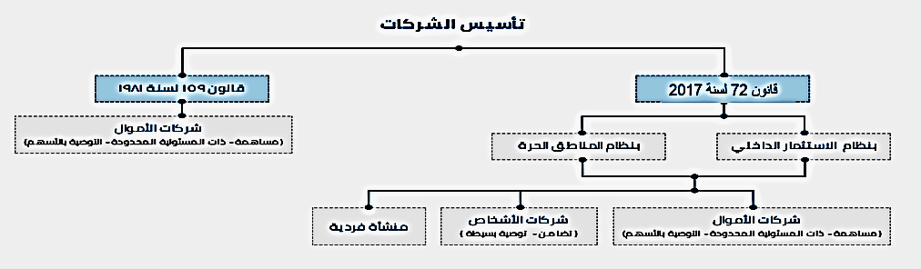

Figure 3 Organization of Company formation

## Formation Procedure

### The needed Documents for Creating a LLC are:

1. Power of attorney: Issued by each Partner
2. Copies of the National IDs of all Partners
3. Proof of purchase for the land/building on which the company will be situated

### Procedure:

1. The preliminary contract is used as a guide for creating the contract
2. Making sure the name is not taken by any other company
3. The creator or agent then creates a bank account and deposits the capital in it which is then frozen
4. The bank informs the GAFI which then issues the needed permits.

## Facilitations offered by GAFI [3]



# Contents of contract

## A Company In law:

A **company** is a **legal** entity formed by a group of individuals to engage in and operate a business

## Contract law

### The keys of contract law

1. The offer
2. The acceptance
3. The consideration

All partners of the contract must be adults (older than 18 years) and of eligibility to participate and therefor:

1. Are partners in the capital?
2. Share revenues or losses.

## Contract purpose

The purpose of partnership agreement (or partnership contract) is to establish a business enterprise through a legally binding contract between two or more individuals or other legal entities. This partnership agreement designates the rights and responsibilities of each partner or entity involved.

## Contract

According to article (16) of law 159, the contract details are announced by the minister and filed according to the executive regulations. A Sample of an announced Contract for a LLC is attached in Appendix II and the whole contract can be found in [2]

# Commercial laws

## Commercial register

Law number (34) issued in 1976 states that each individual who intends to participate in commercial activity should be registered in commercial registry affiliated to his governorate

### Commercial register requirements

Article (3) attached in appendix I dictates that the individual should be an Egyptian.

Other requirements as the place of institution and social status of partners has to be filed, details can be found in law 34 through [4]

## Social insurance

### Requirements

1. Employer registration in social insurance:

Employer insurance shall be compulsory in accordance with Article 5 of Law No. 108 of 1976 can be found through [5] with respect to social insurance for employers and the like, provided that the age of the insured is not less than twenty-one and does not exceed the age of sixty

1. Registration of workers in social insurance:

Insurance in accordance with the provisions of the Social Insurance Law No. 79 of 1975 in the National Organization for Social Insurance is compulsory (article (4) of the Social Insurance Law No. 79 of 1975), and the provisions of the above-mentioned law shall apply to workers subject to the provisions of the Labor Law who meet the following conditions:

1. The age of the insured shall be 18 years and over
2. The work relationship shall be regular, and the work relationship shall be considered regular if the work practiced by the worker enters by nature in the activity practiced by the employer.
3. The contract period shall not be less than one year

### Implications of non-participation in social insurance

In addition to the value of the contributions, the employer is obliged to pay 50% of the contributions which he did not pay as a result of not subscribing for all or some of his workers or performing the contributions on the basis of false wages.

## Taxes Departments

The Income Tax Law is regulated by Law No. 91 of 2005 which can be found through [6]

The Taxes is no dependant on the form which the company takes but on the activity which it is participating in.

### Types of taxes

1. Income tax
2. sales tax
3. Payroll tax
4. Stamp duty

After the government's decision to exempt new and used electric vehicles from customs duties, Dr. Magdy Abdel Aziz, head of the Egyptian Customs Authority, said that electric cars will be exempted from customs duties, but will be subject to VAT.

# Bank Relations

## Bank role:

The general role of commercial banks is to provide financial services to general public and business, ensuring economic and social stability and sustainable growth of the economy. In this respect, credit creation is the most significant function of commercial banks.

## Bank requirements procedure

Creating a bank account is simple and needs:

1. To be of age more than 21
2. A Valid National ID
3. The capital to deposit in the bank

# Labour law

### Definition:

The Labor Code is a set of legal rules governing the relationship of workers with employers, and is a branch of private law that is concerned with regulating the relations of individuals with each other.

Unified Labor Law No. 11 of 2001 article 1 which can be found through [7] States the following:

“In the application of the provisions of this Law, the following terms shall have the meanings indicated:

Each pair:

1. The Worker: Any natural person employed as a labourer or employee.
2. Employer: Any person who issues a public or a propagandist Pay.
3. Pay : Whatever workers receive for their work, whether fixed or variable”

## Requirements

The labor law states enormous rights and duties for each party but to name few:

1. The right to terminate the employment relationship during the probationary period.
2. The right to a copy of the employment contract.
3. The right to social insurance.
4. The right to remuneration for his work (remuneration as defined by the Labor Law).
5. The right to weekly, official, annual and sick leave.
6. The right to work for a period not exceeding the working hours prescribed by law.
7. The right to overtime pay if the worker is forced to work during the holidays or the number of hours in excess of the working hours specified in accordance with the law.
8. The right to reciprocity with those in his or her employment grade without discrimination based on color, sex or religion.

## Application & Reinforcement

The company must have regulatory bodies ensuring the application of the labour law and provision will be provided for the departments in the government responsible for it or else punishments will be applied to reinforce applying the law

# Internal rules and regulations

## Laws:

Issued under Article 55 of the Labor Law No. 8 of 1996, the internal rules law states that:

1. These rules shall be prepared by any institution employing ten or more workers in accordance with the provisions of Article (55) of the Labor Law.
2. This Regulation is concerned with the provisions pertaining to the organization of work only, especially times and times of work, rest periods, holidays, work violations, penalties, and related matters. Organization of work.

## Purpose

Internal laws and regulations of a company are of great importance as it specifies the chain of management and the specific rules followed by each of the partners and the employees, A Legal Agent will be hired to Draft the necessary internal laws for running the company in a legal and appropriate manner.

# *References*

1. [*https://www.gafi.gov.eg/English/MediaCenter/PublishingImages/A%20Companies%20Law%20with%20cover.pdf*](https://www.gafi.gov.eg/English/MediaCenter/PublishingImages/A%20Companies%20Law%20with%20cover.pdf)
2. [*https://www.gafi.gov.eg/Arabic/MediaCenter/News/Pages/laws.aspx*](https://www.gafi.gov.eg/Arabic/MediaCenter/News/Pages/laws.aspx)
3. [*https://www.gafi.gov.eg/Arabic/eServices/Pages/limitedcompanies.aspx*](https://www.gafi.gov.eg/Arabic/eServices/Pages/limitedcompanies.aspx)
4. *https://www.wipo.int/edocs/lexdocs/laws/ar/eg/eg021ar.pdf*
5. *http://www.aun.edu.eg/fgaa/laws/79.pdf*
6. [*http://www.mof.gov.eg/mofgallerysource/arabic/insurance2010.pdf*](http://www.mof.gov.eg/mofgallerysource/arabic/insurance2010.pdf)
7. *http://www.gccegypt.org/Uploads/Laws/32145fddf454df.pdf*

# Appendix I



Figure 4 Article 4 of law 159



Figure 5 Article 16 of law 159



Figure 6 Article 3 of law 79

# Appendix II



Figure 7 Contract Form

# Marketing Study

# Market Overview



Figure 8

Marketing study is a study that analyses market demand for a particular product or service. It analyses the activities in a market in regard to such influences as location, demand, and competition which may or may not affect the value of property. It aims to evaluate the impact of certain marketing instruments on customer behaviour. A marketing study is often associated with the marketing mix. Its purpose is to make a company's marketing process more effective.

The electric vehicle charging station market is expected to record a CAGR of 38.45% during the forecast period, 2019-2024. The electric vehicles (EV) market has been witnessing significant growth, owing to the growing environmental concerns and rising demand for sustainable and energy efficient transportation.

* Growing adoption and sales of electric vehicles, along with the enactment of laws and subsidies for promoting the adoption of EVs and declining cost of batteries, are some of the major factors propelling the growth of the market.
* Global plug-in vehicle deliveries reached 2.1 million units for 2018, which is 64% higher than for 2017, which included all BEV and PHEV passenger cars sales, light trucks in the United States/Canada, and light commercial vehicle in Europe and China.
* This rise in sales has been the result of the enactment of stringent emission norms by governments and environmental agencies, to control exhaust emission levels, and to promote the usage of zero-emission vehicles. For instance, in China, the government to encourage the adoption of EVs among the consumers, made a policy to reimburse 30% of the total value of the electric vehicle.
* Among the regions, Europe is expected to witness the fastest growth rate in terms of deployment of the number of charging stations compared to other regions.

## Growing Sales of Electric Vehicles

Electric vehicle market has witnessed rapid growth in recent years.

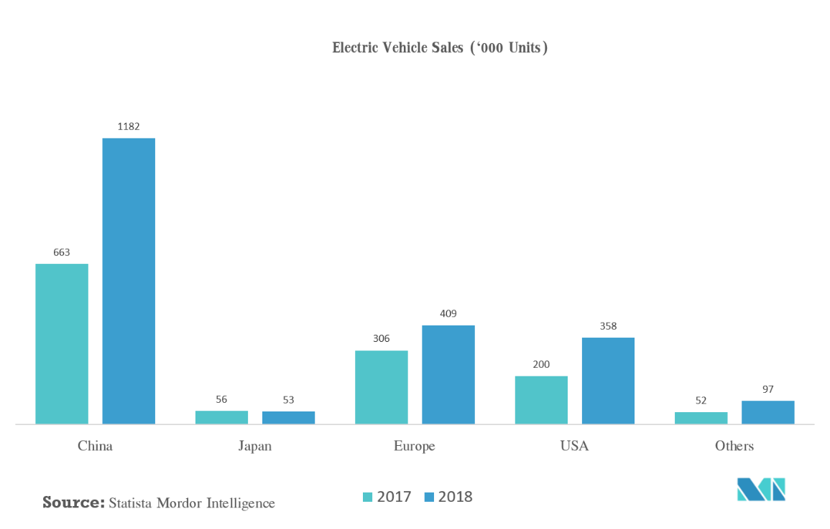

# Marketing Mix

Today, with advent of new technologies and with increased competition, it is found that several organizations are deploying different and innovative marketing campaigns to increase the overall sales of the organization. The top-level management of these organizations need to launch new marketing strategies that will help them overcome the market challenges, market competition, and will also fulfil the sales objectives of the organization.

The organization, further, needs to conduct market research before directly implementing the marketing plan for the given products of the organization. They need to determine the price, promotional strategy, place of promotion, and identify key features of the product that will help them attract more customers toward the given product.

Also, the marketing team of the organization needs to make sure that they are not only able to achieve required objectives of the organization but are also able to achieve the objective of sustainability in a given work environment.

The company needs to overcome different marketing challenges of the environment and accordingly place the products in the market so that they can easily target them to the intended customers in a given market. This report will discuss the marketing plan and will identify key marketing strategies that will assist the organization in achieving desired marketing objectives of the organization.

## Marketing Mix Tactics

### Product

* The organization will be launching different product models that will have different performance capacities. Second, these products deliver high performance, offers other functionality compared to other vehicles, and also saves on pollution. Apart from design, technology, and quality, the product also offers safety and convenience to the customers.
* Today, it is found that the issue of pollution related to different vehicles has increased in a given environment. Even, customers have become more aware of it and are searching for better products in the market that can help them resolve this issue. Hence, they might switch to such electric vehicles that can provide with similar performance, quality, and also assist in controlling pollution in a given environment.
* Hence, the marketing department of the organization needs to focus on the aspects of controlling pollution and delivering high performance while preparing the marketing plan of the organization. They also need to demonstrate visuals and other forms or presentation to spread more awareness on the given product.

### Price

* The pricing of the product should be kept in alignment with the prices of other vehicles. Apart from the functionality of the given product, the top-level management can highlight certain features of the product such as technology, design, style, and other such features. It is important to deliver the message of sustainability through utilization of such vehicles to the intended customers.
* It will help the company to remain competitive in the market environment and subsequently achieve more sales for the given products in the organization. It is important for the marketing team to determine the prices of other products in the market. They can also invest in research and development so that they can develop price-centric products for the customers.
* The customers will be able to afford such products and hence the company can thereby target to a larger segment. It will subsequently help them achieve required targets from the sales perspective (Garay & González, 2012). However, the marketing team needs to monitor the pricing strategies on a frequent basis so that they can make necessary changes as and when required.

### Promotion

* This is one of the major elements of the marketing mix and plays a vital role in the sales of the products. The company needs to focus on the aspects of advertising and promotions and thereby prepare the marketing plan to sell the electric vehicles in the market. Advertisements will help the organization to increase the awareness levels of the products in a given market.
* Similarly, promotions will help the company to introduce new launching offers in the market. The customers should be informed about such offers through different forms of advertisement. However, the marketing team also needs to take into account budget considerations and constraints before preparing the promotions plan for a given product. They need to thereby choose the marketing channels wisely and subsequently manage them from the budget perspective (Liu et al., 2010).
* The costs associated with such forms of marketing are high and it is important for the marketing team to determine the most appropriate marketing channels and mediums. They also need to allocate budgets separately for digital marketing to reach the intended target audience.
* Further, they also need to look out for promotions through in-store advertisements and thereby capture the attention of the audience. It is important to communicate the desired message of advertising and promotions through such means to these customers to achieve required sales targets for the organization.

### Place

* The organization needs to identify the places through which they will be able to sell these products. It is important to determine the stores and other such places from where these products can be delivered to the customers.
* Further, the top-level management in association with the marketing department needs to identify the cities from where these products will be sold to the customers. They can thereby prepare the marketing strategies for each of the stores and accordingly sell the products from different locations.
* They need to hire regional managers that will be looking after the sales and other processes of the organization. They will be also reporting to the senior management on the daily and monthly sales updates so that the top-level management can monitor the progress. They can also modify the strategies as and when required.
* It will thereby help them achieve desired sales targets across different stores in multiples cities of a given nation. The marketing team, however, needs to carefully choose each of the store locations and also provide them with necessary support services to exceed the expectations of the customers.

## Conclusion

It is important for the marketing team to communicate clearly about the objectives of the organization to the staff. They need to be trained on the modules of sales marketing, services marketing, and other affiliates form of marketing. Only then they will be able to deliver results as per the expectations of the organization. Further, the marketing team needs to prepare the marketing plan after identifying the marketing mix for the given products - Electric Vehicles of the organization. They also need to undertake the market research before formulating the final marketing strategies of the organization.

The marketing team at the stores need to communicate clearly and explain about the major benefits of the product to the customers. They need to become more social and also focus on the services aspects of the product so that customers can get attracted to buy those products. It is important to think out-of-the-box for promotions to provide the best discount offers to the customers during the launching time.

It is equally important for the customers to get aware of such products and purchase them. The role of the marketing team in a given organization can thereby considered as vital from different perspectives. It will thereby help the organization to achieve required objectives in a given challenging environment.

# Electric-vehicle infrastructure demand

In the European Union, as EVs go mainstream, charging will likely shift toward public options and away from the home over time, with the share of home charging declining from approximately 75 percent in 2020 to about 40 percent by 2030. That’s because more middle- and lower-income households without home-charging options will buy EVs from 2020 onward. In China, public charging will dominate and increase in importance over time, going from 55 to 60 percent in 2020 to approximately 80 percent by 2030. The structural limitations of highly dense urban cities, which have larger proportions of on-street and large-commercial-garage parking, are the catalysts for increased public-charging demand.

In the near term, low levels of public charging should therefore not significantly hinder EV adoption in the European Union and United States. The situation looks different for China, where over half of the energy will come from public sources. Furthermore, the importance of public charging will likely grow stronger by 2030, reinforcing the need for strategies based on target-market needs.

As electric-vehicle demand looks increasingly likely to grow and EVs emerge as viable alternatives to ICE cars, an ecosystem of industries needs to stack hands on actions that can enable their broader use. Closing the charging gap is one such action, and resolving it will require a concerted, collaborative effort. That’s why finding the answers to the questions raised here should top the agendas of all stakeholders across the EV ecosystem, especially if charging access becomes the number-one impediment to EV penetration. Understanding specific local needs for early demand and adaptation will be the key to making effective targeted investments, matching demand and supply, and enabling quick returns on investments.

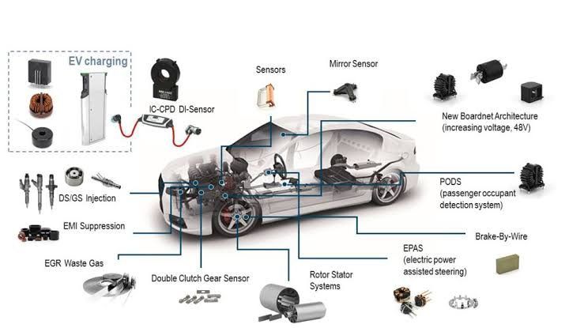

Figure 9 parts of electric vehicle

# SWOT Analysis

We conducted a SWOT analysis to make sure our organization and product would be viable for development. Since our plan is to supply electric vehicle chargers as part of the EV Project, our target market becomes the company with the contract to build the infrastructure. This company is ETEC, part of ECOtality of North America.

Our goal is to win the contract as the supplier of choice for the charging stations. This will provide us with a significant advantage down the road because our chargers will be installed early in the adoption of electric cars. This is the best way to gain market share for us – to get it from the beginning.

Tesla Inc. was an American start-up powered by Silicon Valley. Tesla was named after Nikola Tesla, who was a very successful inventor and scientist of his time. He had remarkable achievements in Radio technology and electrical engineering of Serbian descent.

## Tesla’s Strengths

Let’s start with the strengths of Tesla Inc. that will include the positive aspects of the company, which have reinforced the position of Tesla to become one of the most dominant companies in the world.

The following factors which are believed to be Tesla’s stronger points have ensured the company’s profitability, expansion, and popularity, especially in the long term.

### A Top Employer Company

Any organization is as good as it employs. In the case of Tesla Inc., it is one of the key factors for the company’s remarkable success. Wall Street Journal reports that Tesla has emerged as an ideal company for employees due to its diversity and innovation-encouraging culture. It has recently been listed as one of the ideal places to work, attracting young jobseekers with fresh talents and energy. The company has also been featured in Forbes’ ‘America’s Best Employer 2019’.

## Tesla’s Weaknesses

All the internal factors in a company which causes any damage or bounds performance evaluation are identified weaknesses in the SWOT Analysis. So, these are some of the shortcomings of Tesla’s organizational structure, which reduce its competitiveness and business growth.

### Manufacturing Complications

The higher standard of innovation, the greater will be mechanical complications and production risk factor. Tesla faces continuous launch, manufacturing and production ramp delays while launching their new vehicles and other products. For example, Tesla faced endless manufacturing challenges when they were about to launch Model X, which lead to constant delays for distribution. Similarly, the company went through extreme troubles while manufacturing Model X’s battery module assembly line at Gigafactory

## Tesla’s Opportunities

The opportunity section of this SWOT Analysis emphasizes the emerging chances of growth for the company. It is an external factor which, when identified, can help Tesla to improve its business performance, management structure, and strategic growth and other aspects.

### Sales expansion in untapped Market

The most significant opportunity for the company right now is the Asian market, which is still unsaturated in the field of automotive and renewable energy markets

### Less Expensive Car

Tesla is expensive due to its unconventional reliance on innovation, which requires maximum financial support to entertain new technology.

Recently, Tesla has launched Model 3, which is a more affordable version of Model S with less range, power, and fewer features. However, it is an excellent opportunity for Tesla to expand the size of their audience market.

## Tesla’s Threats

The threat factor is combined with the phenomenon which stops the company from taking full advantages of the benefits that can be derived from the available strengths. Therefore, these are the few threats which Tesla faces to maintain the business despite the unpredictable conditions of the market.

### Product Liability Claims

Despite Tesla’s premium quality assurance and high standards of manufacturing, the automobile industry, in particular, is accustomed to facing significant product liability claims which the company’s fears to be one of the biggest financial blows.

## Conclusion

In this SWOT analysis for the company, we highlighted each of the strength, weakness, opportunity, and threat which Tesla faces in the market. To grow its market share and financial stability, Tesla needs to take vigorous actions. Yet there is no doubt that despite the negative factors, the company is an ultimate symbol of progress and innovation.

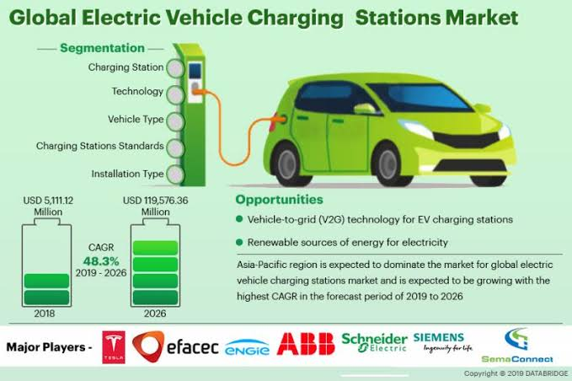

Figure 10 mechanism of action

# Competitor analysis

A competitor analysis is an assessment of the strengths and weaknesses of the current and potential competitors within a defined industry. It can be described as a two-stage framework where the main components are competitor identification followed by competitor analysis.

By identifying, analysing and accumulating knowledge about its competitors a firm can acquire strategic advantages. Competitor identification involves classifying and categorizing companies based on relevant similarities and differences, thereby assisting in creating an awareness of the competitive threats that exist. Competitors can be classified according to how competitive each competitor is deemed to be.

This step can be done by constructing a competitor array or performing competitor profiling, where a two-dimensional matrix can be constructed listing relevant data connected to the competitors.

# Electric vehicle charging stations market segmentation:

The electric vehicle charging stations market is segmented into the following categories:

## Electric Vehicle Charging Stations Market, by Vehicle Type:

* Battery Electric Vehicle (BEV)
* Plug-in Hybrid Electric Vehicle (PHEV)

## Electric Vehicle Charging Stations Market, by Charging Station:

* AC Charging Station
* DC Charging Station

## Electric Vehicle Charging Stations Market, by Installation Type:

* Residential
* Commercial

## Electric vehicle charging stations market, by Region:

* North America
* Europe
* APAC
* RoW

The global Electric Vehicle Charging Stations market is segmented into type of charger, application, power output, supplier type, and region. Based on Type of charger, the global Electric Vehicle Charging Station market is segmented into AC charging station and DC charging station. DC charging station dominated the global Electric Vehicle Charging Station and it is further expected to continue its dominance during the forecast period as well. Based on Type of application, the global Electric Vehicle Charging Station market is segregated into private and public. Public charging station emerged as a global leader as of 2018 with majority of the global market share. Based on Type of power output, the global Electric Vehicle Charging Station market is segregated into <11 kW, 11kW-50 kW, and >50 kW. Market segmentation based on supplier type, the global Electric Vehicle Charging Station market is segregated into OE Charging Station and Private Charging Station.

Geographically, the Electric Vehicle Charging Stations market has been segmented into North America, Europe, Asia Pacific, and Latin America and the Middle East & Africa (LAMEA).

North America dominates the global Electric Vehicle Charging Stations market owing to the increasing number of electric vehicles, stringent government regulations, and presence of electric vehicles manufacturers in the region. The U.S. is likely to hold major share of the North America electric vehicle charging stations market followed by Canada. Growing need of import-export through trucks and other transport vehicles in the U.S. and Canada is escalating the demand for electric vehicles and subsequently electric vehicle charging stations during the forecast period.

Europe electric vehicle charging stations market is the second leading region in the global market owing to the government policies of banning vehicles running on fossil fuels by 2025. Germany is expected to gross the largest share of the market due to increasing demand for electric vehicles and electric vehicle charging stations in the country followed by the U.K.

The Middle East is expected to gross low share of the global Electric Vehicle Charging Station market owing to the presence of ample amount of fossil fuel oil fields in the region.

Latin America is likely to experience significant growth with healthy CAGR owing to the rapidly increasing industrial sector in the region. Africa is forecasted to grow steadily over the next few years owing to increase in the number of favourable government regulations.

# Electric Vehicle Charging Stations Market Growth Forecast to 2023 - DC Charging Station Holds the Largest Market Share

Electric vehicles (EVs) are slowly gaining traction because of increasing greenhouse emission and strict pollution control standards enforced by environmental agencies. The boost in the adoption of EVs has created a favourable growth landscape for the electric vehicle charging stations (EVCS) market as well. The growing popularity and acceptance of EVs has resulted in increased installation of electric vehicle charging stations in the recent past. The global electric vehicle charging stations market is expected to be valued at USD 30.41 billion by 2023, growing at a CAGR of 41.8% between 2018 and 2023.

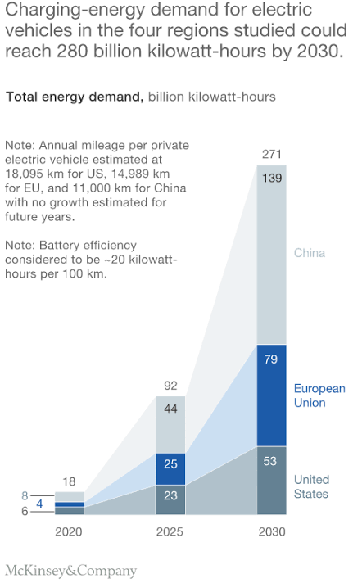

Figure 11 market growth

Key factors driving the growth of the electric vehicle charging stations market include government funding, subsidies, and incentives, growing demand for electric vehicles, growing concern toward environmental pollution, and heavy investment from automakers in EVs. Vehicle-to-Gird (V2G) EV charging stations and charging stations powered by solar panels are the key opportunities for the players in the electric vehicle charging stations market.

Tesla is engaged in designing and developing electric cars and DC fast charging stations for its customers. Tesla is recognized to revolutionize the electro mobility ecosystem by manufacturing all electric production cars. The company's cutting-edge battery technology and electric powertrain, coupled with a rapidly growing fast charging network, has contributed in becoming one of the leading players in the electric vehicle charging stations market.

# References

*1-* [*https://www.mordorintelligence.com/industry-reports/electric-vehicles-charging-stations-market*](https://www.mordorintelligence.com/industry-reports/electric-vehicles-charging-stations-market)

*2-* [*https://www.abcassignmenthelp.com/marketing-mix-tactics-eli-electric-vehicle*](https://www.abcassignmenthelp.com/marketing-mix-tactics-eli-electric-vehicle)

*3-*[*https://www.mckinsey.com/industries/automotive-and-assembly/our-insights/charging-ahead-electric- vehicle-infrastructure-demand*](https://www.mckinsey.com/industries/automotive-and-assembly/our-insights/charging-ahead-electric-%20%20%20vehicle-infrastructure-demand)

*4-* [*https://bstrategyhub.com/tesla-swot-analysis/*](https://bstrategyhub.com/tesla-swot-analysis/)

*5-* [*https://www.marketsandmarkets.com/Market-Reports/electric-vehicle-charging-stations-market-21599205.html?gclid=Cj0KCQjw6eTtBRDdARIsANZWjYYQ9SRts9QTo0fjSjUzsnbq6G\_\_RZk-idTekTzfmKAD1kMtPvBLRvEaAhdrEALw\_wcB*](https://www.marketsandmarkets.com/Market-Reports/electric-vehicle-charging-stations-market-21599205.html?gclid=Cj0KCQjw6eTtBRDdARIsANZWjYYQ9SRts9QTo0fjSjUzsnbq6G__RZk-idTekTzfmKAD1kMtPvBLRvEaAhdrEALw_wcB)

*6-* [*https://www.prnewswire.com/news-releases/electric-vehicle-charging-stations-market-growth-forecast-to-2023--dc-charging-station-holds-the-largest-market-share-300919621.html*](https://www.prnewswire.com/news-releases/electric-vehicle-charging-stations-market-growth-forecast-to-2023--dc-charging-station-holds-the-largest-market-share-300919621.html)

# Technical Feasibility Study

# INTRODUCTION

With the electric vehicle (EV) market becoming more significant especially in Europe over the past years, also the need for charging points is steadily increasing. Infrastructure and demand for EV’s have a “chicken and egg” like relationship as the more vehicles that are on the road, the more demand there is for charging stations, but the amount of charging stations deployed can also hinder the adoption of EV’s. With the EV market becoming more relevant, also the number of charging points has been steadily increasing, and according to association and media reports, there should be about 220,000 chargers by 2020 in western and northern Europe. So our main concern is to implement a sufficient number of charging points over all Egypt to support the electrical cars that our company import.

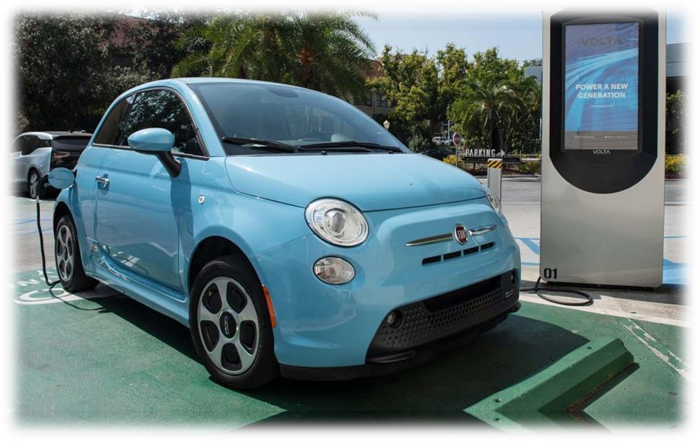

*Figure 1 Example of Charging point and how a vehicle will connect to*

# Charging infrastructure

Developing charging infrastructure requires major investments, and currently there are limited business models for private investment. Governments usually incentivize the installation of charging stations either at residential or public access locations.

The support for the development of charging infrastructure can be first based on ambitious EVs targets and then focused on specific funding for implementation projects. In addition, the need to understand how to best charge, aggregate and control the EV load on the grid is a fundamental and ongoing issue. This would impact important decisions in the development of charging infrastructure – such as where to best place the charging points, which technology to use and how to combine slow smart chargers with fast chargers, to best meet consumer’s immediate needs.

In the UK, the Office of Low Emission Vehicles provides grant schemes to cover part of the cost associated with installing EV charging infrastructure. The Electric Vehicle Home charge Scheme provides residential customers grants that can cover up to 75% of the total procurement and installation costs.

# Types of charging:

A look into the current operating practice reveals four different wired charging modes based on system standard DIN EN 61851-1, referred to as charging modes 1, 2, 3 and 4.

* Mode 1: as charging with a maximum of 16 A using single-phase socket outlets with earthing contact (in most European countries Schuko-socket) or three-phase industrial sockets (e.g. CEE socket). Mode 1 is typically used to charge small electric vehicles such as e-bikes, e-motorcycles or e-scooters. In this mode a RCD (residual current device) is stringently required.
* Mode 2: describes single or three-phase AC charging with double current up to 32 A, also with household or industrial sockets. The main difference compared to mode 1 is that mode 2 uses a special charging cable with an integrated control and protective device. The IC-CPD (In-Cable Control and Protection Device) protects the user from an electrical shock caused by insulation defects if he has connected his vehicle to a power outlet that is not intended for charging.
* Mode 3: covers permanently installed charging stations with a charging cable and specially designed vehicle connections of type 1 and 2. The system includes built-in safety functions, such as a residual current device (RCD). The Equipment is deployed in practice to provide a quick charge with a single or three-phase alternating current of up to 32 A for all commonly used electric vehicles.
* Mode 4: In contrast to charging mode 3, it charges vehicle batteries with up to 400 A DC. For this purpose, the charger is integrated into the station. The other structural features are similar to mode 3: Permanently installed charging station with fixed charging cable, lockable plug-in connections (Combo 2 or CHAdeMO) as well as protective functions within the charging station.

# Standards: to ensure clarity and high standards of Quality

In general, for electrical planning, connections with power ratings above 2 kW have their own circuit. In assessments of single-phase charging stations, the diversity factor is 1. It should also be noted that socket outlets with earthing contact for household purposes use can only be used for short periods with a maximum current of 16 A. If continuous power up to 3.7 kW is required, socket outlets with suitable protections are used (e.g. CEE 16/3). The design of the supply cable must also comply with HD 60364-5-52.

This also includes temperature evaluation after one hour of continuous operation. A maximum temperature increase of 45 Kelvin is tolerable. Possible fire loads can be easily identified using the latest technology.

For these purposes Fluke Corporation (which we will try to implement the same technology from) has developed the new PTi120 thermal imaging camera. Its values can then be easily evaluated and assigned in conjunction with the new Fluke Connect asset tagging software.

# OVERALL IMPLEMENTATION REQUIREMENTS:

## TECHNICAL REQUIREMENTS:

### Hardware:

* Widespread adoption of EVs.
* Public and private charging infrastructure – smart charging points.
* Smart meters – required for supplying interval values for net consumption and net production.

### Software:

* Smart charging services such as energy and power flow management systems that allow for optimal EV charging, ICT systems, intelligent charging infrastructure or advanced algorithms for local integration with distributed energy sources.

### ICT structure and development of communication protocols:

* Agree and develop common interoperable standards (both at physical and ICT layers) as well as clear definitions and roles for actors and smart charging.
* Develop a uniform solution for the method of communication between charge points and the central power system, regardless of the vendor.

## POLICIES NEEDED:

### D Stable, supportive policies for e-mobility and smart charging.

### Strategic policies could include:

* Prioritization of demonstration and commercialization: Increased co-operation between public and private actors could enable the roll-out of large-scale demonstration and pilot projects.
* Win-win synergies and exchanges between the electricity, automotive and manufacturing sectors: the electricity industry should increasingly engage with e-mobility stakeholders in raising awareness and developing best practices with a focus on customer opportunities.

# Detailed IMPLEMENTATION REQUIREMENTS:

## Materials input:

### Charge stations incorporate several assemblies and controllers:

* The power electronics assembly is the guts of a charge station. Functionally, it supplies the power to the EV’s on-board battery charger. Physically, it’s made up of wires, capacitors, transformers and other electronic parts.
* The charge controller serves as the “street smarts” of the charge station. It oversees basic charge functions, like turning a charger on/off, the metering of power usage and the storing of key bits of real-time and event data.
* The network controller provides the brains of the charge station. It enables the station to communicate with its network (via an on-board telecommunications device) so that managers can monitor it and review historical event data. It also controls user access to a charging station through a series of white (authorized) or black (unauthorized) lists.
* The charge station cable and connector plug into the target electric vehicle. These components provide the conduit for a charge to be delivered.

## Classification of electric charging station components:

* Physical components, such as internal electronics, controllers, cord, EV-compatible plug and telecommunications devices to share data and enable network connections.
* Softwareapplications to manage the charging, billing, driver access, and administration of an electric charging station program.
* **O**n-going service to maintain physical and software components as well as provide customer service to both electric charging station owners and their driver constituents.

## Spare parts:

### 4 S A E J 1772 standard – A C charging

* Strictly speaking, Level 1 charging does not require a special charging station. It uses a Level 1 charging cable, which looks like a large laptop power pack cable and plugs into a standard 120-V outlet (CSA 5-15R). If that outlet is dedicated to EV charging, it must be supplied by a 20-A branch circuit (see Section 86 of the Code). Level 2 charging requires a fixed charging station supplied by a dedicated 208-V or 240-V branch circuit.
* All electric vehicles sold in North America are equipped with a J1772 charging socket, except Tecla’s, which require an adaptor. The standard also describes Level 3 AC charging, but no compliant on-board chargers or charging stations are currently available on the market. At these power levels – up to 96 kW – automakers prefer to opt for an external DC charger connected directly to the EV battery.

## Operation of a J1772 charging station

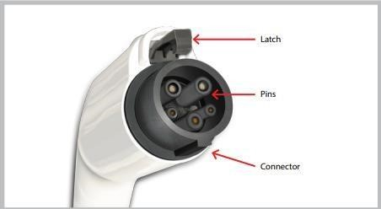

Figure 3 Detail of J1772 connector

When the charging connector (see Figure 3) is in its holster on the station, both it and the cable are completely de-energized and cannot be energized. When it is inserted into the EV socket, the connection is detected by the charging station, which communicates its maximum current to the EV. The EV sends a response signal indicating that it is ready for charging. After this handshake, the connector and the cable are energized and charging begins. Charging is managed by the on-board charger.

# LOCATION ANALYSIS:

When it comes to refuelling a car, drivers of gas- and diesel-powered vehicles have it easy. They roll up to any one of the many gas stations available in different places around all Egypt, pump in liquid fuel in a matter of minutes, and pay either in cash or with a credit card. Unfortunately, it’s a little more complicated with public charging for electric vehicles. **Although** we have to mention that almost all EV charging takes place at home, which usually requires about 30 seconds to plug in each night.

So, from our main goals to be to provide these chargers through our company’s different selling partners all over Egypt, which we will begin to produce in phase 2 of our company. However, the main concern now is to choose the most suitable locations in Egypt to implement the charging stations.

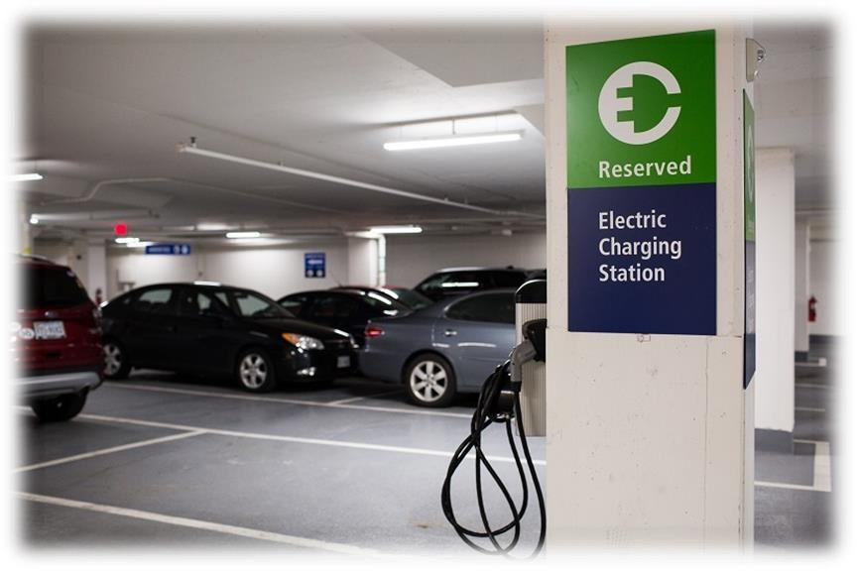

*Figure 6 Example of an electric charging station in a car park*

There’s a lot of science — or should be, at least — behind where, exactly, to put a rapidly growing number of electric-vehicle charging stations.

Automakers, electric utility companies, local and state governments and other parties are embarked on a charging-station building binge, ahead of a hoped-for increase in EV adoption.

But historically, they don’t always end up in the best places, according to San Francisco-based Streetlight Data, a company that tracks and analyses traffic patterns, road use and much more, employing data from people’s mobile devices — primarily phones, as well as data from Internet-connected cars.

### Number of charging stations needed with estimate cost:

Numerous studies have shown that consumers steer clear of EVs because they worry about the lack of charging stations. Studies also show that consumers are more likely to buy an electric car when they see stations around town. While fears about range anxiety are largely unfounded–even the cheapest EVs sport enough range to serve nearly all of a driver’s needs– the paucity of charging stations is a real concern on longer trips, and it is deterring consumers from going all-electric.

And – According to homeadvisor.com – the electric car charging station will cost around $436 - $984, according to the location and the method of charging used.

So, our goal is to implement as many charging stations as we can all over Egypt (according to the investment given in the economical & financial feasibility study), with at least:

* 1 charging station in each governorate
* 1 charging station in each main high way

(Ex: Cairo/Alexandria Agriculture road - Cairo/Alexandria Desert road - Cairo/Red Sea High way)

* 3 charging stations in the capital or most crowded cities (ex: Cairo)
* 2 charging stations in the highly crowded cities (ex: Alexandria)

And the exact places/streets where the station will be implemented will be calculated using **Factor Rating** strategy for the options given in each territory, with **Factors** like:

* Land cost
* Traffic volume
* Size
* Layout

In conclusion, our target is to implement 40+ charging stations all over Egypt, with estimate cost of $40,000 in the installation phase.

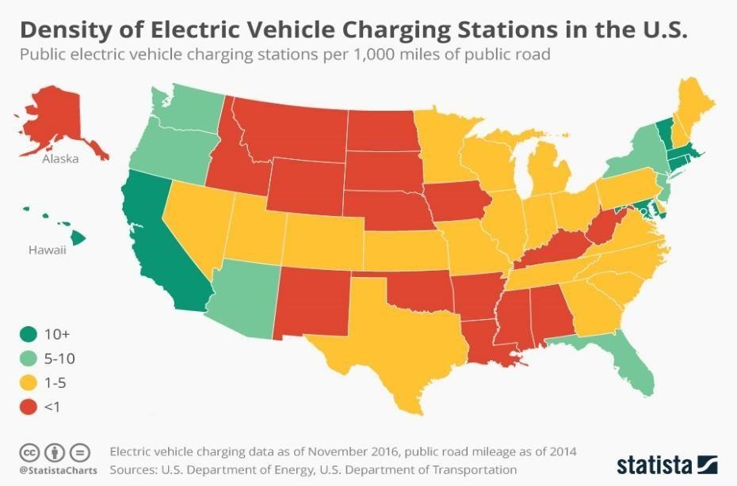

*Figure 7 Density of electric charging station in the U.S. in November 2016*

## Positioning of the charging station:

The first things we have to consider are safety, accessibility and comfort of your guests. In general it is suggested that the length of the electric line (the distance from the charging station to the next distribution box) is as short as possible. It is ideal to place the charging station halfway between two parking lots (with sufficient space in front) to allow charging of different types of electric vehicles.

If the charging station is not waterproof, it is necessary to provide adequate weather protection. To provide a more comfortable charging experience, you may also decide to light and protect the charging point.

Resources needed:

### Electricity:

Electricity is the main resource in the charging stations, and there are 2 ways to get electricity:

1- Use common electricity resources:

By making a contract with the government to buy electricity with a reduced price. (Not our main source of energy, but important to increase efficiency) **2- Use renewable resources of electricity:**

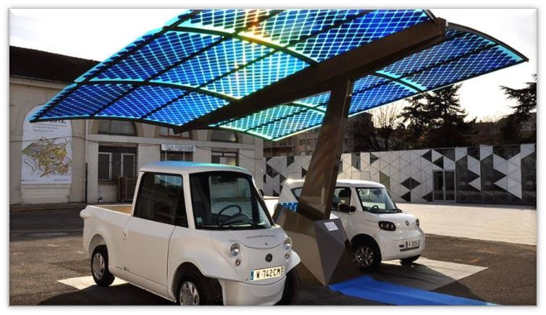To be truly respectful of the environment, and to our name **‘ ECO STREETS ‘** electric vehicles must be recharged with clean energy, that is coming from renewable sources (photovoltaic, wind or hydroelectric). For this the installation of a charging station must be accompanied by the choice of a 100% clean electricity supplier, or by the installation of a clean energy production plant.

And, one of the best solutions (that we will use) is **solar panels**, with price in 2019, reaches $2.99/watt.

Figure 8 **design for an EVCS using Solar panels**

# Labour:

Human labour is needed in each station in form of:

* Manager for each station
* Working in the station for helping the guests
* Workers for maintenance

Conclusion:

We have found that the installation time for electric charging stations will not take much time and we will, therefore, start immediately after the legal approval throughout the order proposed in the marketing feasibility study.

Electric vehicles are here to stay but installing and commissioning the necessary charging stations requires electricians to have a suitable level of expertise. This applies to both the private and public sectors. Public charging stations especially demonstrate how important initial tests and regular periodic tests are. In the future, it will become increasingly important to be able to determine a fault in charging circuits safely and quickly using flexible measuring technology.

# References

1. [*https://www.gafi.gov.eg/English/MediaCenter/PublishingImages/A%20Companies%20Law%20with %20cover.pdf*](https://www.gafi.gov.eg/English/MediaCenter/PublishingImages/A%20Companies%20Law%20with%20cover.pdf)
2. [*https://www.gafi.gov.eg/Arabic/MediaCenter/News/Pages/laws.aspx*](https://www.gafi.gov.eg/Arabic/MediaCenter/News/Pages/laws.aspx)
3. [*https://www.gafi.gov.eg/Arabic/eServices/Pages/limitedcompanies.aspx*](https://www.gafi.gov.eg/Arabic/eServices/Pages/limitedcompanies.aspx)
4. *https://*www.wipo.int/edocs/lexdocs/laws/ar/eg/eg021ar.pdf
5. http://www.aun.edu.eg/fgaa/laws/79.pdf
6. <http://www.mof.gov.eg/mofgallerysource/arabic/insurance2010.pdf>
7. <http://www.gccegypt.org/Uploads/Laws/32145fddf454df.pdf>
8. <https://www.plugincars.com/ultimate-guide-electric-car-charging-networks-126530.html>
9. [https://www.forbes.com/sites/jimhenry/2019/10/31/putting-electric-vehicle-chargingstationswhere-people-will-actually-use-them/#1f9ab9bd22b8](https://www.forbes.com/sites/jimhenry/2019/10/31/putting-electric-vehicle-charging-stations-where-people-will-actually-use-them/#1f9ab9bd22b8)
10. <https://blog.arlingtontransportationpartners.com/properties-stand-out-with-ev-charging-stations>
11. <https://www.homeadvisor.com/cost/garages/install-an-electric-vehicle-charging-station>
12. <https://www.statista.com/chart/6586/electric-vehicle-charging-infrastructure/>
13. <https://ecobnb.com/blog/charging-stations-electric-vehicles-guide/>
14. https://news.energysage.com/how-much-does-the-average-solar-panel-installation-cost-in-the-u-s/

# Financial Statements

|  |  |  |  |  |
| --- | --- | --- | --- | --- |
| Eco Streets, LLC | | | | |
| Income statement | | | | |
|
| Fiscal Years ending 31 December | | 2025 | 2026 | 2027 |
| Revenues | |  |  |  |
|  | Net sales | $15,000,000 | $14,500,000 | $15,500,000 |
|  | Cost Of sales | $10,650,000 | $10,295,000 | $11,005,000 |
|  | Gross Profit | $4,350,000 | $4,205,000 | $4,495,000 |
| Expenses | |  |  |  |
|  | Rent Expense | $300,000 | $300,000 | $300,000 |
|  | Depreciation Expenses | $90,000 | $90,000 | $90,000 |
|  | Adminstrative Expenses | $240,000 | $250,000 | $26,000 |
|  | Advertising Expenses | $10,000 | $10,000 | $15,000 |
|  | Insurance Expense | $30,000 | $30,000 | $50,000 |
|  | Salaries expense | $1,260,000 | $1,260,000 | $1,600,000 |
|  | Total expenses | -$1,930,000 | -$1,940,000 | -$2,081,000 |
| Net Income before taxes | | $2,420,000 | $2,265,000 | $2,414,000 |
|  | Income Taxes | $242,000 | $226,500 | $241,400 |
| Net Income after taxes | | $2,178,000 | $2,038,500 | $2,172,600 |

|  |  |  |  |  |  |  |  |
| --- | --- | --- | --- | --- | --- | --- | --- |
| Eco Streets, LLC | | | | | | | |
| Balance Sheet | | | | | | | |
| Assets | | | | Liabilities | | | |
|  | 2025 | 2026 | 2027 |  | 2025 | 2026 | 2027 |
| Cash | $1,000,000 | $976,000 | $2,281,000 | Accounts payable | $3,008,000 | $2,089,500 | $4,309,600 |
| Supplies | $50,000 | $40,000 | $70,000 | Income Taxes | $242,000 | $226,500 | $241,400 |
| Accounts recievable | $10,000,000 | $9,000,000 | $10,000,000 | Total Current Liabilities | $3,250,000 | $2,316,000 | $4,551,000 |
| Inventory | $200,000 | $300,000 | $200,000 | Owner's Equity | | | |
|  |  |  |  | Eco Streets, capital | $8,000,000 | $8,000,000 | $8,000,000 |
|  |  |  |  |  |  |  |  |
|  |  |  |  |  |  |  |  |
| Total Assets | $11,250,000 | $10,316,000 | $12,551,000 | Total liabilities and OE | $11,250,000 | $10,316,000 | $12,551,000 |